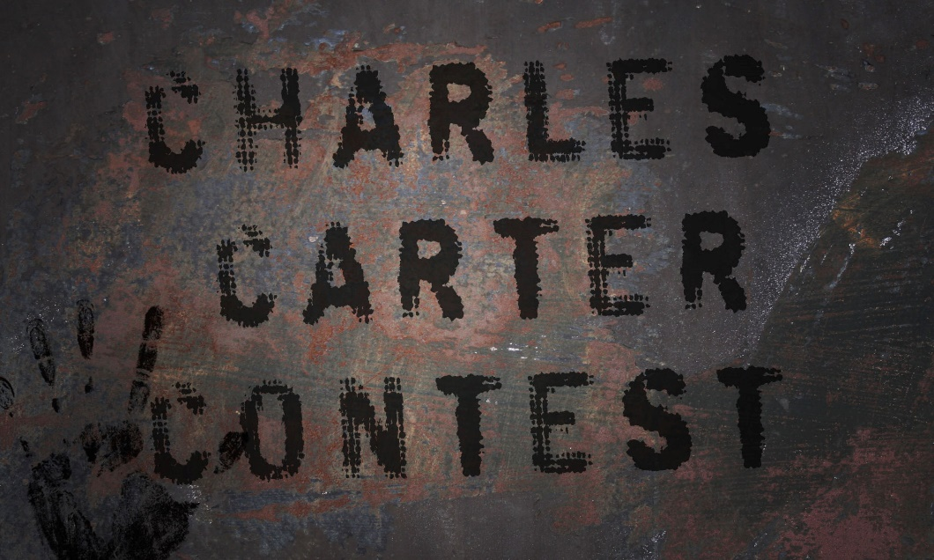

**Letters from Postapocalypse**

*Content*

The Charles Carter: *a working anthology* will be accepting submissions of ***unpublished*** work for our Letters from Postapocalypse contest! Welcome, creators, to the contest of end-time letters. What happens when everything ends? What happens far after? With a story, a poem—any form of anything written, capture for us the Postapocalypse. Show us society’s reconstruction. Show us the final collapse. Bring us your take on the grand finale, and may your entry, above all others, survive.

Submit @ <http://www.thecharlescarter.com/contest-submissions/>

Entry Fee: None!

*Dates*

09/10/17 – Submissions open

11/15/17 – Submissions close

12/01/17 – Winners announced

*Formatting*

Accepted file types: .docx/.rtf/.pdf

Length must not exceed 5000 words

Documents should be double-spaced, 12 size font, Times New Roman

Include name on submission form but not in body of document

No limit to submissions!

*Prizes*

1st

* Publication
* Piece featured in our Winner’s Circle
* Author Interview
* Prize Money! ($15.00 USD)

2nd

* Publication
* Piece featured in our Winner’s Circle
* Prize Money! ($5.00 USD)

3rd

* Publication
* Piece featured in our Winner’s Circle